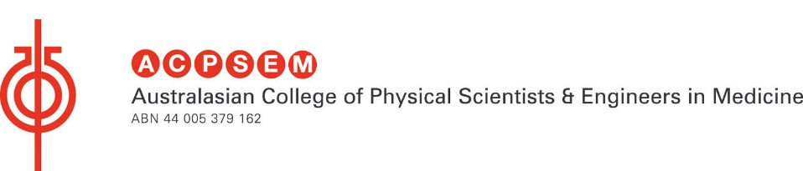

Most Outstanding Analysis Award in Physics

$150 Award for a Year 7-12 student

Presented by the Australasian College of Physical Scientists & Engineers in Medicine (ACPSEM)

The science carried out by Medical Physicists requires accurate analysis to ensure the best diagnosis, treatment and outcome for patients.

The Most Outstanding Analysis Award in Physics will be awarded to a student that demonstrates the best Scientific Analysis and Communication in the field of Physics. Scientists and Engineers in the field of medicine are skilled in analyzing and interpreting data from medical imaging scans (such as CT, MRI and PET scans), as well as collecting and understanding complicated output data from radiation treatment units. As medical scientists, we are looking for the student who possesses the keen ability to perceptively analyze experimental data.
This can include, but not limited to:
- Analysis and interpretation of experimental work.
- Critical analysis or review of work conducted in the field of health physics.
- Investigation of experiments that relate to the basic principles of health physics
  - E.g. Study of Motion, Energy and Force that can be related to medicine, sport, or modern day society.
- Creative efforts that demonstrate ingenuity to collect data.

The prize will only be awarded if more than one student applies. The award will not be given to the same student who has previously won the ACPSEM award.

For more information on the work carried out by our Scientists and Engineers in Medicine ACPSEM, please visit our website http://www.acpsem.org.au/

