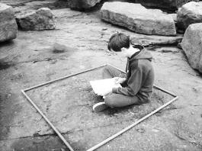
STANSW Young Scientist Awards – Scoring Sheet
Years 10-12 *Survey
* Scientific Investigations that are primarily surveys, e.g., field surveys, astronomical surveys

Category: Biology Chemistry Earth & Environmental Science Physics (Please circle one) Project ID
10-12 Survey
Type of Entry: Individual Team (Please circle one)
Student Name(s):
School Name: Assessor’s Name
Project Title:

Evidence – Place a tick in the most appropriate region for each criteria scale
10-12 *Survey Judging Criteria | High Level Satisfactory Poor Level
Well-defined aims
Clearly expressed the subject of the investigation
Included clear, concise and relevant background research
Identified and assessed a range of sampling techniques
Convincing arguments for selected procedure and technology
Research showed originality in selection of site
Performed a considered risk assessment
Methodically gathered data in planned sample areas
Recorded data logically using standard mapping techniques
Research showed creativity in data collection procedures
Classified sample areas identifying features of interest and variants
Analysed and evaluated trends and patterns in collected data
Performed a recognised statistical distribution analysis
Critically synthesised information to evaluate procedures
Suggested directions for additional survey procedures
Acknowledged the source and type of any assistance given
Logbook details stages of surveying process
Used clear, concise and meaningful language and visuals
Completed a valid and systematic survey of an area of interest
Addressed an issue of social or scientific significance
Exhibited deep understanding of related science concepts

“The strengths of your survey include:” (circle two numbers from the list or write two comments)

“Next time you could improve your entry by:” (circle two numbers from the list or write two comments)

Nominations for Sponsored Awards Concerns (e.g. ethics, animal welfare, safety) Score (1/2/3/4) Score:

