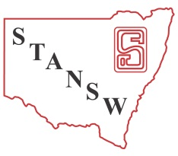
STANSW Young Scientist Awards – Scoring Sheet
Years 3-6 Models and Inventions
3-6 Models and Inventions
Project ID
Type of Entry: Individual Team (Please circle one)
10-12 Survey
Student Name(s):
School Name: Assessor’s Name
Project Title:

Evidence – Place a tick in the most appropriate region for each criteria scale
3-6 Models and Invention Judging Criteria | High Level Satisfactory Poor Level
Identified a need or problem
Developed a solution that was useful to society or a group
Showed an innovative or creative approach
Gathered relevant background information
Evaluated originality of their design by comparing with related inventions that already exist
Carefully selected materials
Actively designed and built working model of an invention
Employed quality and safe construction skills
Produced a model that was easy to use and performs as intended
Succinctly communicated operational details of model
Critically tested the model and discussed improvements made
Logbook details stages of inventing process
Acknowledged any assistance given
Demonstrated good understanding of science concepts

“The strengths of your invention include:” (circle two numbers from the list or write two comments)

“Next time you could improve your entry by:” (circle two numbers from the list or write two comments)

Nominations for Sponsored Awards Concerns (e.g. ethics, animal welfare, safety) Score (1/2/3/4) Score:

