STANSW Young Scientist

How does Water Temperature Affect How Clean Your Hands are?

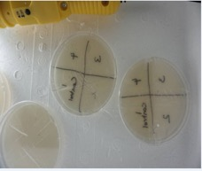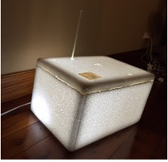

By Eshwari Surendran

Year 4

MLC Burwood

How does Water Temperature Affect How Clean Your Hands are?

Background Research
Washing your hands is good hygiene practice. Everyone washes their hands many times a day to prevent them from catching an infection. I wanted to find out if washing your hands in warmer water leaves fewer germs on my hand. As part of my research I sited many articles. There was one article that was interesting which suggested that washing hands between 40 °C – 45 °C leaves cleaner hands than at higher temperature or lower temperatures. I could not test it to see if I could wash at higher temperatures than 45 °C.

One article suggested that modern soaps are designed to lather at 35 °C, compared to lower or higher temperature. It can be the extension to my experiment next time, and I can try out different brands of soap.

Another article suggested that at higher temperatures the water molecules, soap molecules and dirt would move faster, making it easier to get the dirt off the skin.

Another of the article suggested washing hands in running tap water was less effective than using a bowl of warm water, as the temperature of the water will drop to room temperature as it touches the skin and drains. Washing in a bowl of water will retain the temperature.

Hypothesis
The prediction is that washing hands in hot water will make the hands cleaner than when washed in warm or cold water.

What Variables am I going to:

Change: The temperature of the water.

Measure or observe: The bacteria growing on the petri dishes.

Keep the Same:
- The time taken to wash your hands
- The amount of soap used (1 squirt)
- The amount of time spent playing with dog
- Quantity of water

Equipment Used:

- Petri dish with agar jelly
- Water
- Soap
- Stopwatch
- Thermometer
- Permanent Marker
- Camera/iPhone to take photos
- Bowl
- Sticky tape
- Jug to measure water
- Paper towel

Method:
- Drew 2 crossing lines on the base of both the petri dishes and labeled each sector 1, 2, 3, 4.
- Measured one liter of cold water and poured it into a bowl. A thermometer was placed in the water and a squirt of soap was added to the water.
- Played with the dog for 5 minutes.
- The petri dish 1 was opened and left index finger was lightly pressed against the agar jelly in the quadrant marked sector 1 of petri dish No. 1. The petri dish was quickly closed. The petri dish 2 was opened and the right index finger was lightly pressed against the agar jelly in the quadrant marked sector 1 of petri dish No. 2. The petri dish was quickly closed.
- The temperature of the water was noted.
- Hands were washed for 20 seconds in the bowl of cold water.
- Hands were wiped/ pat dried on a paper towel.
- Repeated step 4 except the index finger was lightly pressed against sector 2 instead.
- Steps 3, 5, 6, 7 and 4 were repeated except warm water was used to wash the hand and the index finger touched sector 3.
- The steps 3, 5, 6, 7 and 4 were repeated again but this time hot water was used to wash the hands and the index finger touched sector 4.
- Using clear sticky tape all 4 petri dishes were taped.
- All 4 petri dishes were then placed in a Styrofoam box with a light bulb and a thermometer.
- The temperature was noted a two times a day and was recorded. We also looked for any growth in the petri dishes every day and took photographs.

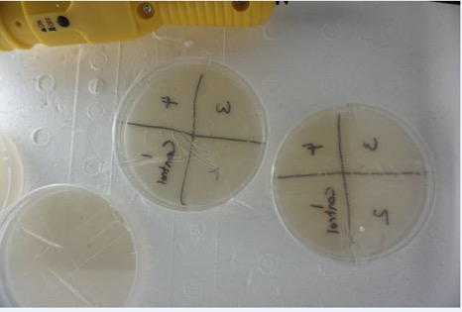

Petri dishes in the Styrofoam

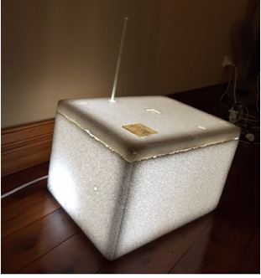

Styrofoam box with thermometer

The picture at the top shows how we placed the petri dishes in the Styrofoam box along with the light bulb to maintain a temperature in the Styrofoam box between 25 – 30 °C.

The picture at the bottom shows the Styrofoam box and the thermometer we used to record the temperature
Readings / Data:

We repeated the experiment three times, so we could look for trends and anomalies.

Set 1 reading

I touched sector 1 with a finger, straight after playing with the dog. This means hands were not washed before touching sector 1.

Volume of Water | Amount of soap | Time playing with dog | Time washing hands | Temperature of water | Sectors
1 liter | 1 squirt | 5 minutes | 20 seconds | 25 C | Sectors 2
1 liter | 1 squirt | 5 minutes | 20 seconds | 35 C | Sectors 3
1 liter | 1 squirt | 5 minutes | 20 seconds | 45 C | Sectors 4

Temperature reading in Styrofoam box:

Date / Time | 13/7  19:00 | 13/7  22:00 | 14/7  6:30 | 14/7  20:00 | 15/7  6:30 | 15/7  20:00 | 16/7  6:30 | 16/7  20:00
Temp. °C | 30 | 30 | 28 | 27 | 26 | 27 | 26 | 27

Date / Time | 17/7  6:30 | 17/7  22:00 | 18/7  11:00 | 18/7  20:00 | 19/7  8:30 | 19/7  20:00
Temp. °C | 28 | 27 | 28 | 27 | 26 | 27

Set 2 readings

I touched sector 1 with a finger, straight after playing with the dog. This means hands were not washed before touching sector 1.

Volume of Water | Amount of soap | Time playing with dog | Time washing hands | Temperature of water | Sectors
1 liter | 1 squirt | 5 minutes | 20 seconds | 23 C | Sectors 2
1 liter | 1 squirt | 5 minutes | 20 seconds | 30 C | Sectors 3
1 liter | 1 squirt | 5 minutes | 20 seconds | 42 C | Sectors 4

Temperature reading in Styrofoam box:

Date / Time | 26/7  18:30 | 27/7  6:30 | 27/7  19:30 | 28/7  20:00 | 28/7  6:30 | 29/7  20:00 | 29/7  6:30 | 30/7  20:00
Temp. °C | 30 | 27 | 28 | 27 | 26 | 27 | 26 | 27

Date / Time | 30/7  6:30 | 31/7  7:00 | 31/7  17:00 | 1/8 7.30
Temp. °C | 27 | 28 | 30 | 26

Set 3 readings

I touched sector 1 with a finger, straight after playing with the dog. This means hands were not washed before touching sector 1.

Volume of Water | Amount of soap | Time playing with dog | Time washing hands | Temperature of water | Sectors
1 liter | 1 squirt | 5 minutes | 20 seconds | 15 C | Sector 2
1 liter | 1 squirt | 5 minutes | 20 seconds | 32 C | Sector 3
1 liter | 1 squirt | 5 minutes | 20 seconds | 43 C | Sector 4

Temperature reading in the Styrofoam box:

Date / Time | 6/8  16:30 | 7/8  7:30 | 7/8  18:30 | 8/8  8:30 | 8/8  22:00 | 9/8  9:30 | 9/8  18:00 | 10/8  7:30
Temp. °C | 25 | 25 | 27 | 26 | 27 | 25 | 27 | 26

Date / Time | 10/8  18:30 | 11/8  7:00 | 11/8  17:00 | 12/8  7:00
Temp. °C | 27 | 27 | 28 | 26

Note: Dish 1 had the right hand prints & Dish 2 had the left hand print.

Results / Observation:

I observed the petri dishes twice a day and also took photos.

SET 1 of the Observations

DAY 1 – 13th July 15
The two petri dishes below were used as a point of interest as one of them was contaminated. You could see a growth clearly in Dish A. Dish B

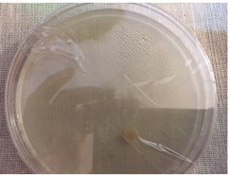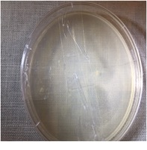

Dish A Dish B

The two dishes I used did not have any visible contamination.

Day 2 – 14th July 2015.

No signs of growth in any of the 4 sectors in the 2 petri dish I am using for the experiment.

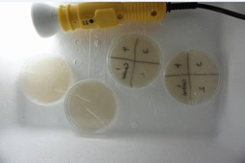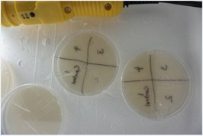

Day 3 – 15th of July 2015

There was growth in Sector 1 in both the petri dishes used for the experiment. There was a white patch and light yellow spores. The growth not visible in the picture.

The Petri dishes used as point of interest had moisture droplets in them.

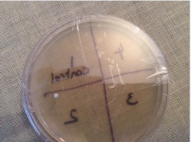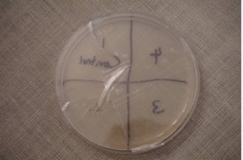

Dish 1 Dish 2

Day 4 – 16th of July 2015

There was growth in both Petri dishes. Sector 1 (control sector) had more growth than on day 3. The sector 2 & 3 also had growth. No visible growth in Sector 4 (hand washed in hot water). One of the Petri dish had more growth compared to other.

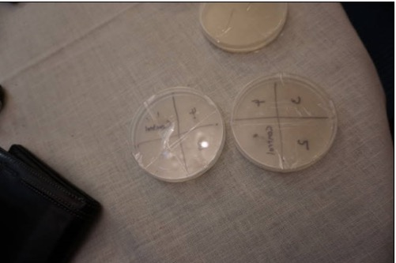

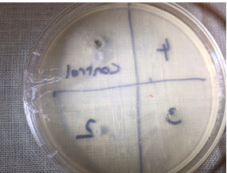

Day 5 – 17th of July 2015

I could clearly see growth in both petri dishes. Dish 2 had growth in all 4 sectors. However Sector 1 (control unwashed hand) had the most followed by Sector 2 (cold water) then Sector 3 (warm water) and Sector 4 (hot water) had the least. Dish 1 also had growth but not clear in the picture.

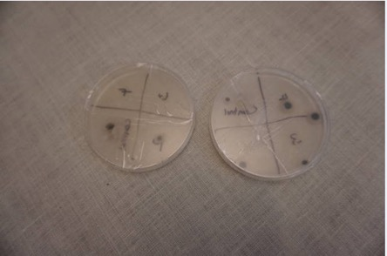

Day 6 – 18th July 2015

I could clearly see growth in all the sectors. Dish 2 has more growth compared to Dish 1.

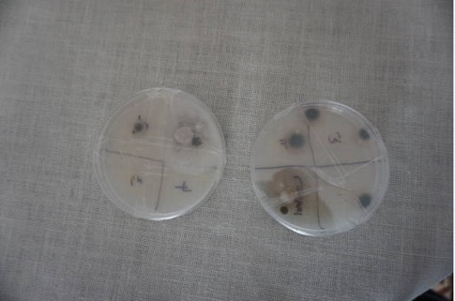

Day – 7 19th July 2015

Today is the final day of my readings. The 2 petri dishes I used as point of interest did not show much of growth in the 7 days. A picture of the petri dishes is below.

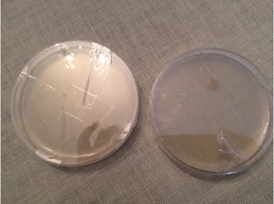

The picture below shows the two petri dishes I used for the experiment.
- Dish 1 – sector 1 is full of growth and is spreading into sector 4. Sector 2 had the 2nd most growth. Sector 3 had growth that is not visible in the picture. Sector 4 had the least except the sector 1 spreading into the boarder of sector 4.
- Dish 2 – There was lot of growth in black and covered with white growth so not visible in the photo. Sector 2 had the next most growth followed by Sector 3 and Sector 4.

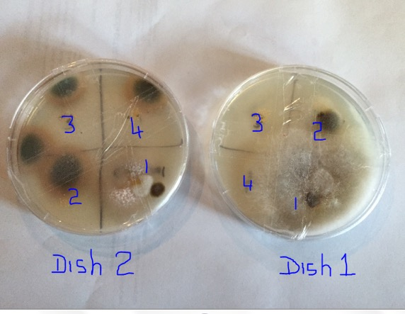

Set 2 of the Observations

DAY 1 – 26th July 15

Both Petri dish 1 & 2 were clean and did not see any growth.

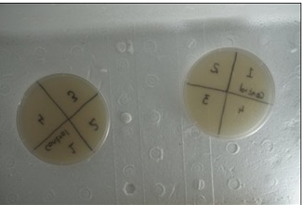

DAY 2 – 27th July 15

Dish 1: Sector 1, control has visible white/off white spores, Sector 2 has less spores than Sector 1. Sector 3 had less specks / spores than Sector 2. Sector 4 had just one speck / spore. I also noticed a bit of condensation.

Dish 2: Sector 1, control had visible spores, sector 2 has less spores than sector 1. Sector 3 had less spores than sector 2. Sector 4 had no visible spores.

The spores / specks cannot be seen in the photograph. I had to shine a torch light under the petri dish to see the growth, it was not very visible.

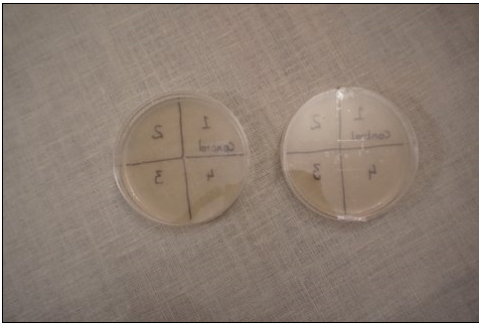

Day 3 – 28th July 15

I saw more growth in both dishes compared to day 2. Not visible in the photograph

Dish 1: Sector 1 had the most growth a blob of pale yellow patch and surrounded by specks. Sector 2 had a smaller blob surrounded by pale yellow spores. Sector 3 had a bigger blob than in sector 2 but less spores surrounding. Sector 4 had the least amount of growth. Appearance of a white cloud at the top of the dish

Dish 2: control, Sector 1 had the most growth, followed by Sector 2, then Sector 3 and the least amount of growth in Sector 4. Sector 4 had no visible growth.

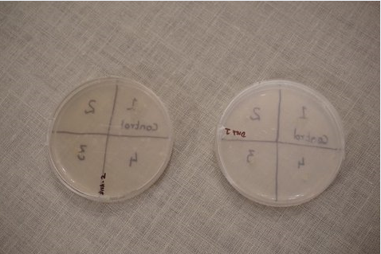

Day 4 – 29th July 15

Dish 1: There was black growth and a yellow blob in Sector 1. Sector 2 also had a black growth and a yellow blob but less growth than in Sector 1. Sector 3 had more yellow blob but less than Sector 2, and very little black growth. Sector 4 had a black speck and a yellow blob. Dish 1 had a cloud forming in the petri dish.

Dish 2: Sector 1 had mostly black and pale yellow growth. Sector 2 had a yellow growth and a bit of the black growth (not visible on the photo). Sector 3 had yellow growth and no visible black growth. Sector 4 had no visible growth at all.

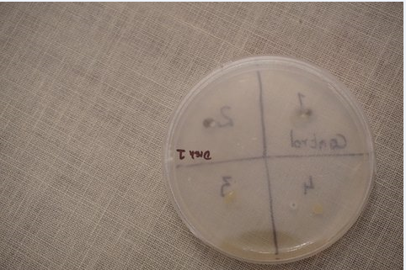

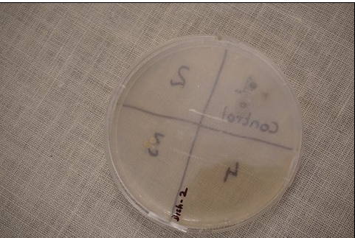

Day 5 – 30th July 15

Dish 1: As you could see the cloud has taken most part of Dish 1. The visibility was very poor. By shining a small torch light under the petri dish visibility was a bit better. Sector 1 had the most growth black and yellow. Sector 2 was hardly visible as there was a thick white cloud. Sector 3 had a yellow blob and a black speck. The cloudy growth was less in sector 3 compared to Sector 2. Sector 4 had less cloud than in Sector 3, but had a yellow and a black growth.

Dish2: Sector 1 had the most growth followed by Sector 2 and 3. Sector 4 still had no visible growth.

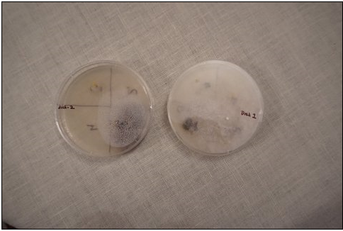

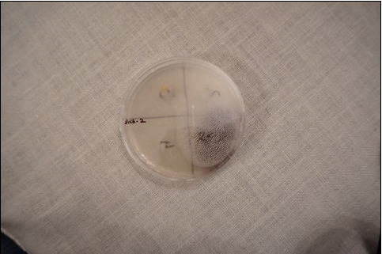

Day 6 – 31st of Aug 15

Dish1: The cloudy growth has spread to the full petri dish. Clearly Sector 1 had the most growth. Since the cloud was all over the petri dish growth in sectors 2, 3 & 4 is NOT only due to the germs on my finger. It could have come from the germs in the cloud.

Dish 2: Sector 1 has covered with black and yellow growth. Sector 2 had less growth compared to sector 1, and Sector 3 had less growth compared to Sector 2. Sector 4 did not have any visible growth a couple of yellow specks. A bit of growth spread from sector 1 near the border of sector 4.

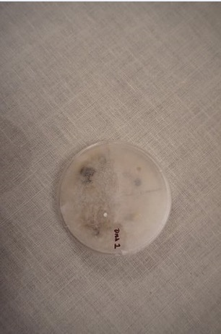

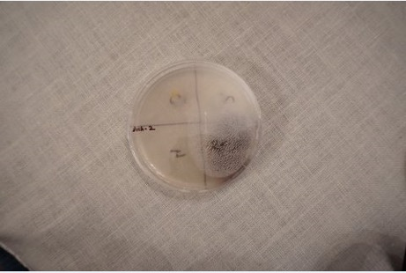

Day 7 - 1st of Aug 15

Dish 1: The cloud of growth is very dense. Visibility was poor.

Dish 2: clearly the growth in Sector 1 is the most followed by sector 2 and then 3. It is interesting to note that there is still very little growth in Sector 4, a few specks not visible on the photo.

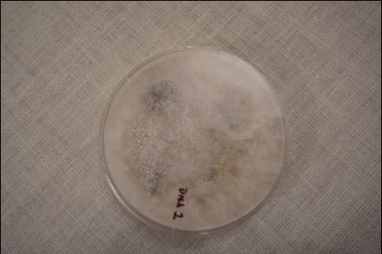

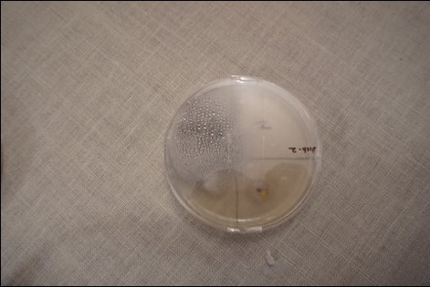

Set 3 of the Observations

DAY 1 – 6th Aug 15

Petri dish 1 & 2 had no visible growth.

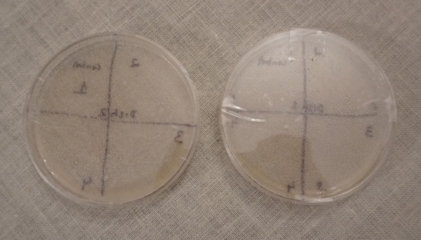

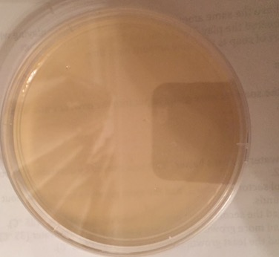

The above petri dish was used as a point of interest / control. There is no contamination introduced as part of the experiment. This is to prove if we did not touch with the finger on this petri dish there will be very little or no growth after 7 days (duration of our experiment cycle).

DAY 2 – 7th Aug 15

Petri dishes 1 & 2 had no visible growth

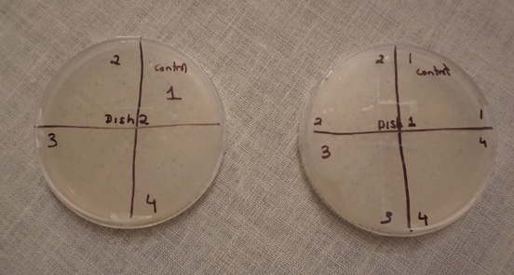

DAY 3 – 8th Aug 15

Dish 1: There was a yellow growth that may be 2-3 mm across in Sector 1. There was less growth in sector 2 however not visible in the photograph. No visible growth in Sectors 3 & 4.

Dish 2: There was a yellow growth in Sector 1 not visible in the photograph. No visible growth in Sectors 2, 3 & 4.

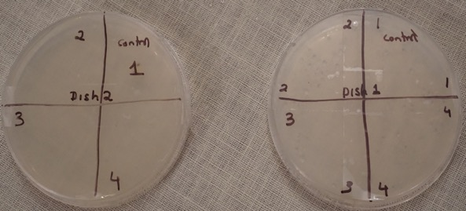

DAY 4 – 9th Aug 15
Dish 1: Sector 1 has growth that is yellow and fairly large spread say 4 mm not visible on the photograph. Sector 2 has black and yellow growth but the area of the growth in sector 2 is smaller than sector 1. Sectors 3 & 4 still no visible growth.

Dish 2: Sector 1 has large amount of black growth surrounded by white haze. Sector 2 has yellow specks not visible on the photograph. Sector 3 has couple of tiny specs and Sector 4 has no visible growth

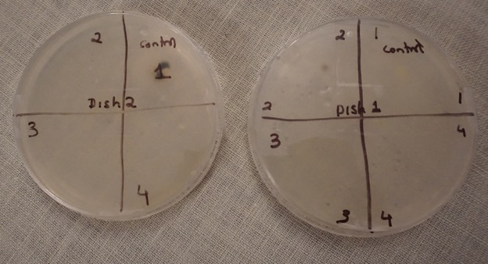

DAY 5 – 10th Aug 15
Dish 1: Sector 1 has black growth surrounded by a cloudy substance. Sector 2 has black growth and a small yellow growth surrounding it. Sector 3 has a few yellow spores. Sector 4 has no visible growth.

Dish 2: There was a black growth surrounded by cloudy growth in Sector 1, that was covering whole of sector 1. A few small yellow specks were visible in sector 2 not visible on the photograph. No visible growth in Sectors 3 & 4.

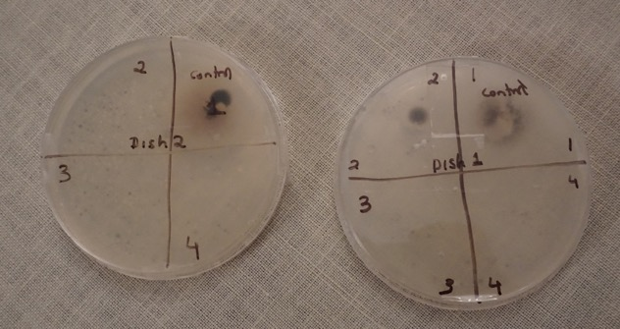

DAY 6 – 11th Aug 15

Dish 1: The growth in sector1 had become like black soot. The growth has entered into the border of Sectors 2 & 4. However Sector 4 did not have any growth. Sector 2 did have a black patch, 1 cm diameter. Sector 3 did not have any visible growth.

Dish 2: Sector 1 had a black spot 1 cm in diameter surrounded by a gray haze covering most of sector 1. Sector 2 had a yellow speck about 1 mm diameter. No visible growth in Sector 3 & 4.

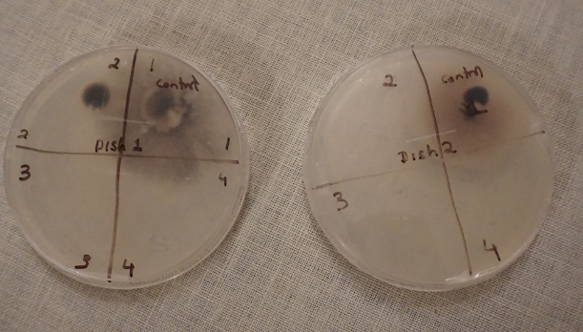

Day 7 – 12th Aug 15

Dish 1: It is clearly seen that the growth in Sector 1 has spread into sector 2, sector 3 and sector 4. However Sector 2 had a prominent black growth, while sectors 3 & 4 were mainly due to Sector 1 growth spread.

Dish 2: Sector 1 had the growth spreading into sector 2 and sector 4. Sector 2 had some small amount of black and yellow growth which is not visible in the photograph. Sector 3 had some yellow specks and sector 4 had no visible growth besides at the border of sector 1.

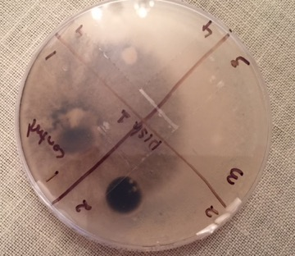

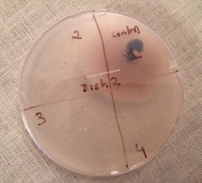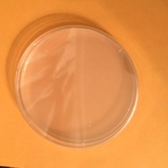

The control petri dish placed on the yellow sheet has no visible growth. This petri dish was not opened and has no contamination during the length of the experiment for 7 days.

Challenges:

One challenge was to keep the petri dishes at temperatures between 25 °C and 30 °C. My parents and I came up with a solution. We put a light bulb in a Styrofoam box with a thermometer and recorded the temperature over a couple of days at day and night. We had to try out different light bulbs until we found a bulb where the temperature remained between 25 °C – 30 °C. The bulb that gave the correct temperature range was Phillip’s 4W Cool White LED globe.

Assumptions:

- I would have the same amount of dirt on my hands after playing with the dog – repeated the play 3 times for the 3 temperature readings
- The squirt of soap is the same amount each time.

Improvements:

We could measure the soap with a syringe and add it into the bowl of water. We could measure 5 ml of soap. This would make us show that we used the same amount of soap each time.

I could avoid the contamination between the sectors by having one petri dish for each temperature reading in which I washed my hands.

Risks:
I thought of few risks that are worth mentioning;
- The risk of contracting some infection from the growth in the petri dishes. Here are the steps I took to reduce the risk:
- I always washed my hands after handling the petri dishes to observe the growth. Once the experiment was completed I returned the petri dishes unopened to the lab to dispose of the content.
- I disinfected the working surface
- Kept petri dishes closed at all times
- Sealed them with two strips of sticky tape
- Risk of burning my hands when washing in hot water. The highest temperature I washed my hands was 45 °C. I would not go any higher.
- The risk of Styrofoam box used to keep the petri dishes catching fire when trying out different bulbs. The first incandescent bulb we used was 40 watts. The temperature in the box reached 40 °C within couple of hours.

Discussion of Results:

The experiment was repeated three times, to look for consistencies and any abnormality. I also had petri dishes as a point of interest in Set 1 and Set 3 of the experiment where no contamination from outside was introduced. I never opened these petri dishes.

The petri dishes that I used as point of interest in set 1 & set 3 did not have any bacterial growth or had very little. This proves that the petri dishes I used had almost no bacteria in them.

It was consistent in all three sets of the experiment that sector 4, which contained the bacteria from the hands washed in hot water (42 – 45 °C) left the least amount of bacterial growth. Sector 1, which had the bacteria without washing hands, had the most amount of growth. There was so much growth on the 7th day in Sector 1 it could have contaminated other sectors. I could avoid the contamination between the sectors by having one petri dish for each temperature reading in which I washed my hands.

As an extension of this experiment I could vary the length of time washing the hands and have the temperature constant.

Conclusion:

The warmer the water the better it cleans. This was proved by observing the growth in Petri dishes 1 & 2 in the three set of experiment.
- The control sector – Sector 1, had the most growth – without washing hands.
- Sector 2 had the second most growth – washed in cold water (15 -25 °C).
- Sector 3 had less growth than sector 2 - washed in warm water (30 -35 °C).
- Sector 4 had the least growth - washed in hot water (42 - 45 °C).

The experiment proves my hypothesis stated at the beginning of the experiment;

“The prediction is that washing hands in hot water will make the hands cleaner than when washed in warm or cold water.”

Bibliography

http://info.debgroup.com/blog/bid/337804/Is-Hot-Water-More-Effective-for-Washing-Hands

http://health.howstuffworks.com/skin-care/cleansing/basics/hand-washing2.htm

https://www.reddit.com/r/askscience/comments/2vt45y/why_does_hot_water_clean_better_than_cold_water/

Acknowledgments with the Experiments
Thank you:

- Mrs Philippa Miller - being a mentor and offering general guidance to the experiment.
- Mr Doug Finlay for being a mentor.
- Mrs Mary Correa - high school laboratory technician at MLC Burwood for providing me with the Agar petri dishes & thermometer.
- My parents - for helping me to set up a Styrofoam box with the bulb.
- My dog Jag who provided me with some germs / dirt.

Log Book

Date/ Month | Description
18/2/15 | I met with Mrs Miller and Mr Finlay to learn about the young scientist competition.
25/2/15 | I looked at some Young Scientist Competition Winner’s investigations for ideas.
4/3/15 | I looked at some websites to help me decide a topic for investigation. Some ideas are:  - What is the best temperature to wash hands in  - Which Detergent cleans up the best  - Which solution removes stains the best; 2 tsp. of either detergent, bi carbonate soda or vinegar, 1 tsp. of vinegar & 1 tsp. of bi carbonate soda, or water. Mrs Miller & Mr Finlay recommended that I do the first idea - “What is the best temperature to wash hands in?”
22/4/15 | I decided on my topic with Mrs Miller. My topic was: “To determine if water temperature affects how clean your hands are.” I also did some background research on the topic.
May | It was decided that, to observe the bacteria growth we would use agar plates. We would also take photos as a recording of the growth.  Mrs Miller contacted the laboratory technician, Mrs Correa, to source some agar plates and a thermometer.  Mrs Miller provided me with a planning sheet for the experiment.
June | Experiment was drafted onto planning sheet.
 | Mrs Correa said that the agar plates should be kept in an area between 25-30°C. My parents and I realized that as it was winter, the room temperature was below 25°C. My parents did some research and decided that a Styrofoam box with a light bulb would keep the agar plates within the required temperature range.
 | To see what light bulb would work, we put a thermometer in the Styrofoam box with the light bulb. The first light bulb rose up to 40°C after 2 hours. As that was not the desired result, we continued to try out different light bulbs. The light bulb that finally had the desired result was a Phillip’s 4 W Cool White LED globe.
July 13- 19 | We commenced the first set of the experiment. We recorded readings up to day 7. By day 7 the growth was covering almost the whole agar plate, so we decided to stop.
July 26-August 1 | We commenced the second set of the experiment.
August 6- August 12 | We commenced the third set of the experiment.
August 12 | Published final report

