STANSW Young Scientist – Primary Young Scientist Award

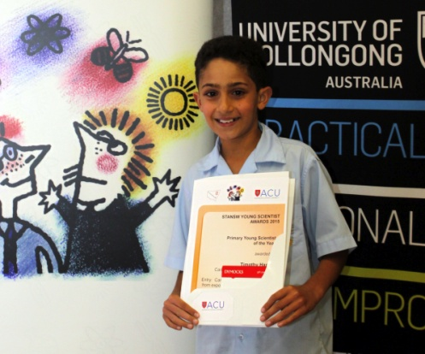
Timothy Hanna, Caringbah North Public School, Can ‘resting’ resistant bacteria from exposure to an antibiotic induce susceptibility once more? (Overall best 3-6 project)

Timothy investigated if antibiotic resistant bacteria can become susceptible, once again, to an antibiotic if given a ‘resting period’ in which generations of bacteria are allowed to grow from resistant bacteria without further exposure to the antibiotic. His results indicated that, after ‘a resting period’, the bacteria Escherichia Coli was susceptible to antibiotics.

