Automated Sprinkler System
BHP Billiton Science and Engineering Awards Entry

James Ruse Agricultural High School (NSW)
Sabiqul Hoque

Automated Sprinkler System
Contents
The Problem 1
Solving The Problem 2
Solving Plant Requirements 3
Limitations 7
Bibliography 7

The Problem
I found that the school automated sprinkler system was inaccurate and inefficient, being only timer based. Some further research and I found some reports on the efficiency of current home based soil moisture systems. “The turf quality … below the minimum acceptable level” (Lailhacar & Dukes, 2013).
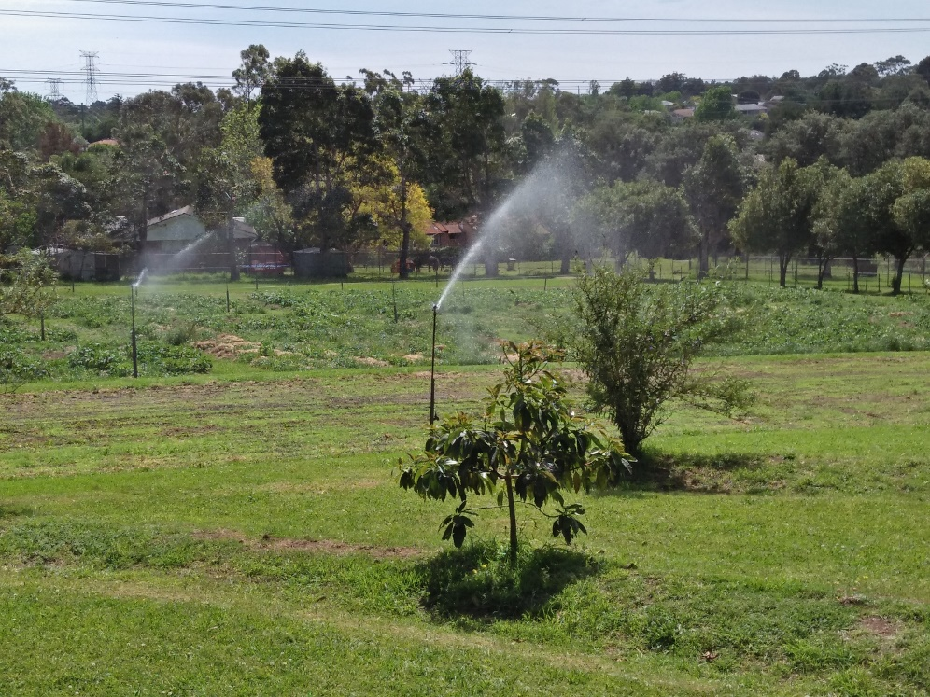

Solving The Problem
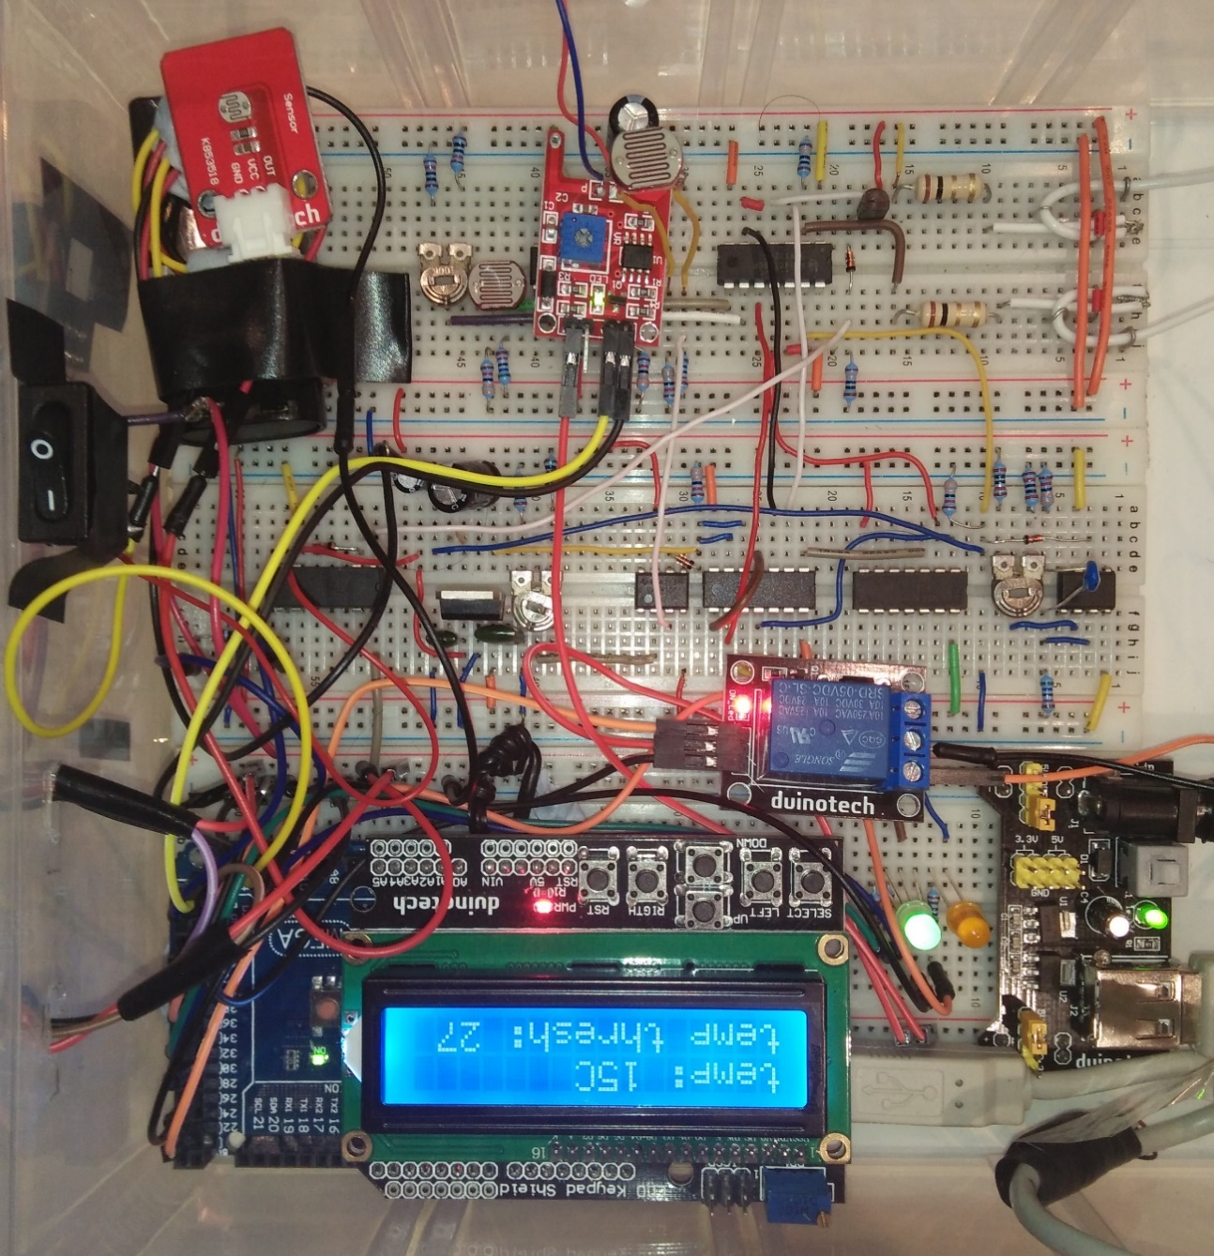
Originally my project was made to work along with the school based system to determine when the soil is wet and turn it off when this happens. If it rains the soil becomes wet and thus it also doubles up as a rain detector. But then I decided to make it independent of the school system. I made a light intensity sensor to identify when it is day or night and later a temperature sensing circuit. All together through a series of logic gates it would turn on a pump under certain conditions as shown in the table on page 3. I then added Arduino sensors and components and eventually an LCD display with pushbuttons. The circuit diagram is on page 5 and one will notice that there are many N-AND gates, this is because N-AND gates are ‘universal’ logic gates indicating that they can be used to make any other logic gate. As the 4011 has 4 2-input NAND gates, I use them to make AND gates and as NOT gates

.

Solving Plant Requirements
Plants transpire most during the day and when there is extremely low humidity or high temperature. Hence my system while detecting for rain and soil moisture, it also measures humidity, temperature and light intensity. During the day the pump is turned on until the soil becomes wet or it rains in which case the pump turns off. It also turns the pump on during the night if and only if the humidity or temperature is high and the soil moisture is low and it is not raining. These conditions are indicated by an RGB led and an orange LED.
LED COLOURS | DESCRIPTION | PUMP
Green | Day, soil is dry and not raining | On
Turquoise | Night, soil is dry, not raining, high humidity or temperature | On
Blue | Night, soil is dry, not raining, normal humidity and temperature | Off
Orange | Soil is wet or it’s raining | Off
Orange and Red | Error indicates that there is conflicting data from the sensors | Off
Red | In all other states | Off

Operating the System

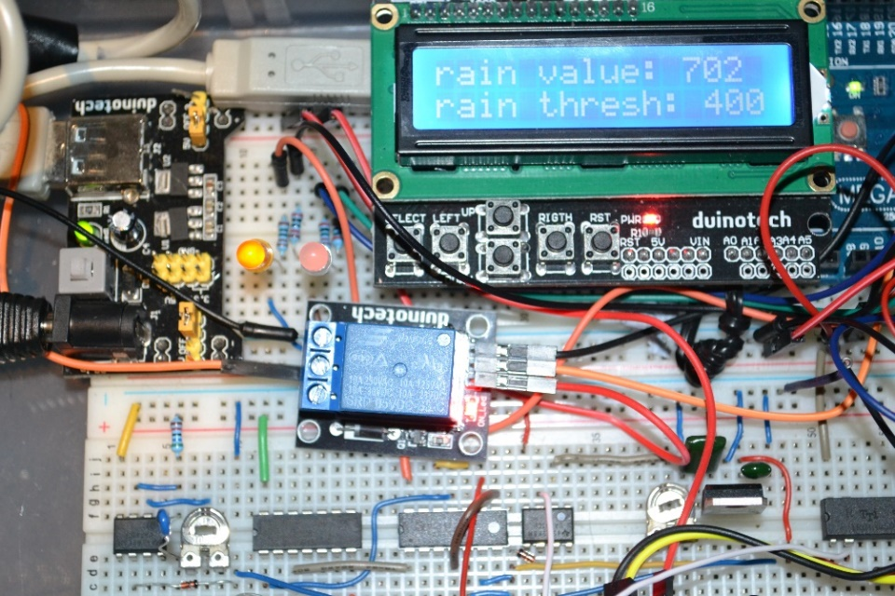
The system is separated into two units; the Arduino unit and the ‘previous’ circuit. Both systems have to be on for the system to operate. The power buttons are shown in green. The threshold value is changed by pressing the up and down buttons (in red). The threshold value is the value at which the temperature or humidity will have to pass to be considered as hot, humid etc. The current sensor value is also displayed as above the threshold on the LCD (see images). There are five screens: temperature, humidity, soil moisture, brightness and rain intensity (there is also an error screen). To navigate between these screens, press the right and left buttons (shown in yellow). There is a reset button to reset the threshold values to the default, pre-set values.

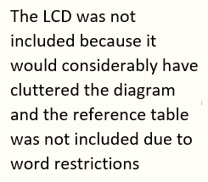
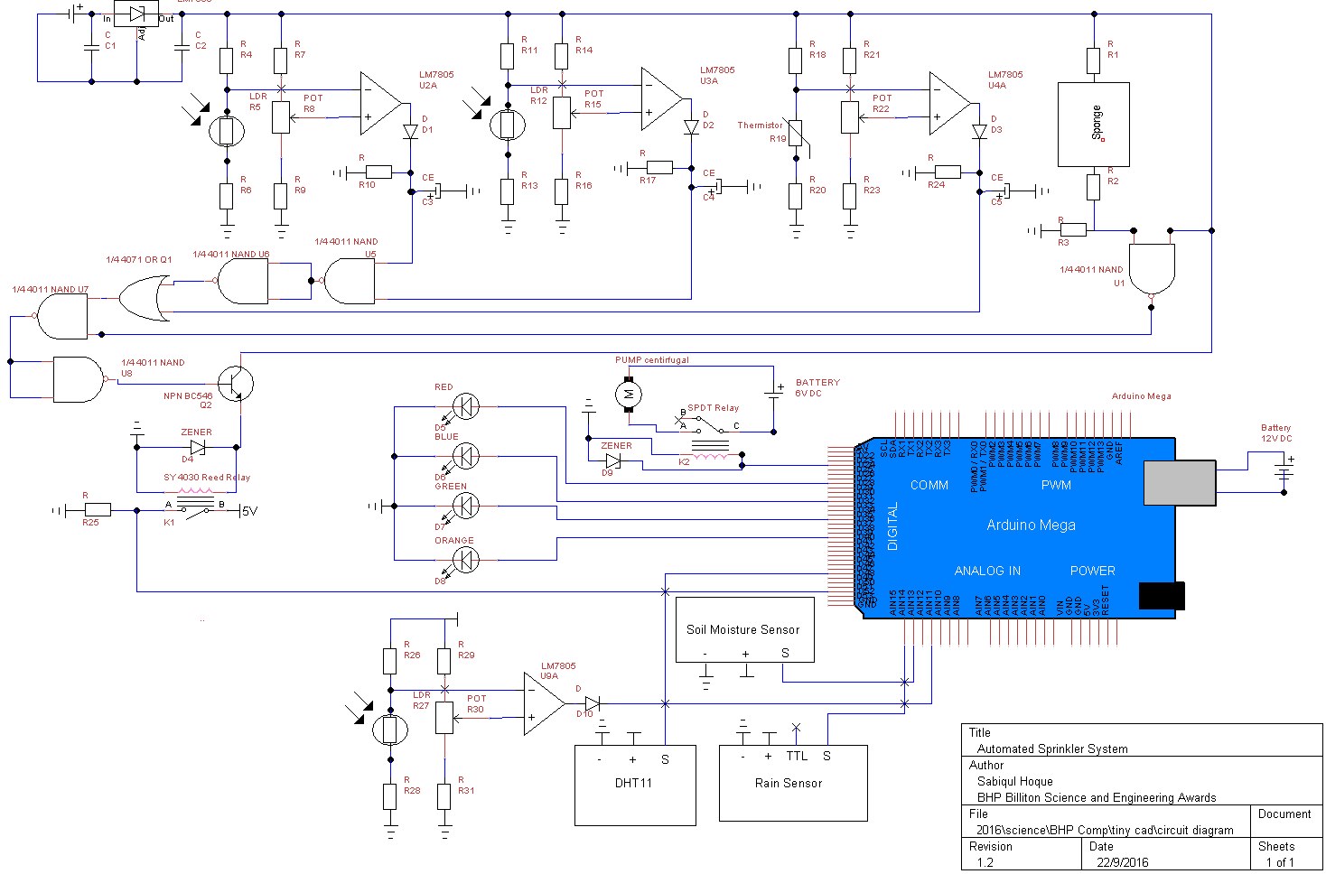

Risk Assessment
There are not many risks with the electronics. The voltage throughout is either 3.3V or 5V. Yet one would want to be careful with the power supply leads from the 9V and 12V power sources, making sure they do not touch or in any way short circuit. The pump is slightly dangerous in that the shaft rotates quickly. The propellers are covered but the shaft has a small piece of wire protruding (highlighted in red). I could not cut it out but I did bend it. One must make sure to handle the pump with care and only touch the shaft when spinning at the base.
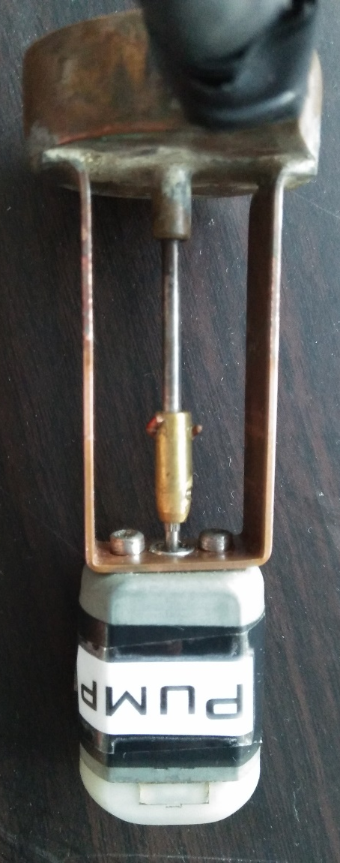

Limitations
It may be easier for users to use their smartphone to control the system and make adjustments to the thresholds. As well as this I could also make it log the data onto an SD card and send this to a smartphone or computer. I could also add internet capabilities so that a user could use his or her phone to monitor and control the automated sprinkler system.

Bibliography
Lailhacar, B. C. & Dukes, M. D., 2013. Soil Moisture Sensor Landscape Irrigation Controllers: A Review of Multi-Study Results and Future Implications, s.l.: ASABE.

Acknowledgments
This project could not have been completed from the consistent moral support from my parents. I would also like to thank my teachers, Miss Kong and Mr Hutchinson for giving me ideas regarding my projects such as submerging the sponge (I rejected this idea). I would also like to thank the Jay Car staff, who helped me select the right components such as a 100K or 10K LDR etc.

