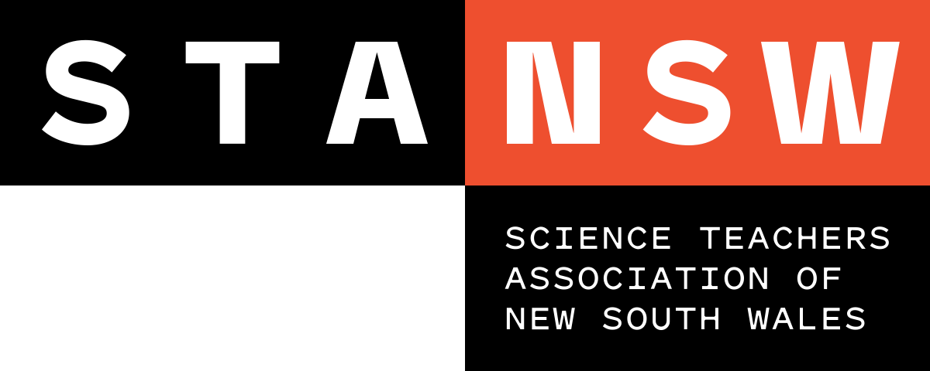

Young Scientist Awards

JUDGING RUBRIC: STANSW Scientific Investigation - Years 3-4

Level | Description
5 | The st The student has provided clear and convincing evidence that they:  - completed a well-planned scientific investigation that incorporated fair testing  - had shown originality in the idea and creativity in the investigative methods  - had a good understanding of the science concepts related to the investigation  - gathered relevant background information and made reasoned predictions  - carefully selected materials and equipment  - accurately gathered experimental data in an appropriate number of trials  - systematically recorded data, including the correct use of units  - analysed data, suggesting plausible explanations for the results  - made valid conclusions and suggested useful applications  - documented each stage of the investigative method in a log book  - acknowledged all assistance given  - used effective communication skills taking into account, purpose and audience
4 | The st The student has provided substantial evidence that they:  - completed a planned scientific investigation that incorporated some fair testing  - demonstrated some innovative or creative aspects  - had a reasonable understanding of the related science concepts  - performed some relevant background research and made an appropriate prediction  - selected suitable materials and equipment  - collected meaningful and sufficient data  - correctly recorded data  - discussed possible reasons for the results  - analysed data and came to a valid conclusion  - included a log book detailing the different stages of the investigation process  - acknowledged any assistance given  - used effective language and formatting to communicate with the intended audience
3 | The st The student has provided evidence that they:  - completed a scientific investigation that contained elements of fair testing  - had shown glimpses of innovation or creativity  - demonstrated an understanding of the science concepts used in the investigation  - collected background research with some relevance to the subject of investigation  - made some form of a prediction  - used suitable equipment  - collected and recorded first-hand data  - proposed sound explanations for the data collected  - provided supporting documentation in the accompanying log book  - acknowledged some of the assistance that was given  - used appropriate language to communicate with the intended audience

JUDGING RUBRIC: STANSW Scientific Investigation - Years 3-4

Level | Description
2 | The st The student has provided evidence that they:  - completed a scientific investigation with limited evidence of fair testing  - set the investigation in some sort of scientific context  - collected fragments of background research  - attempted to make a prediction  - gathered data but was unable to clearly present it  - offered sketchy explanations for the data collected  - presented a logbook that was either fragmented or too brief  - informally mentioned assistance given  - used language and formatting that did not connect with the intended audience
1 | The st The student has provided evidence that they:  - attempted an investigation with a lack of understanding of fair testing  - had inadequate understanding of the related science concepts  - failed to gather first-hand data  - offered explanations for results that could not be experimentally supported  - did not maintain a suitable log book  - failed to acknowledge assistance given

