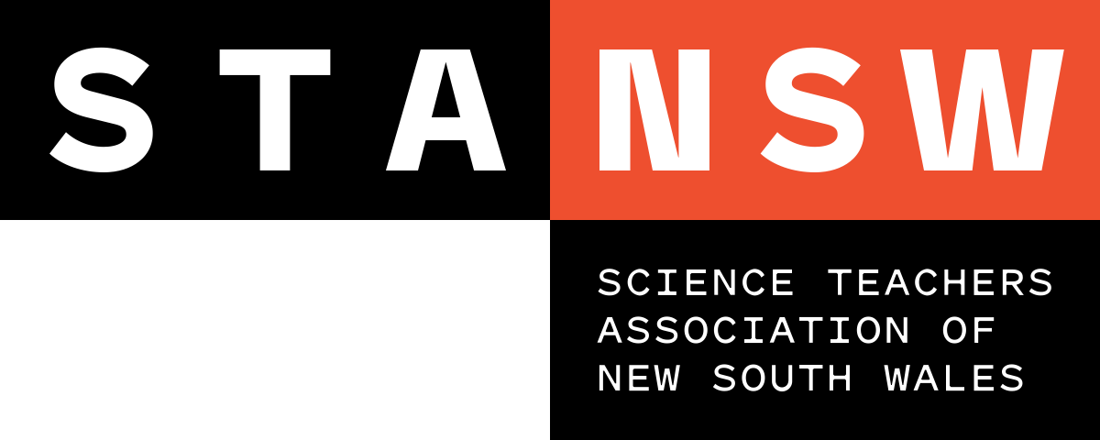
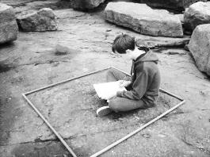
Young Scientist Awards

JUDGING RUBRIC: STANSW Scientific Investigation - Survey, Years 5-6
Level | Description
5 | The student has provided clear and convincing evidence that he/she:  - completed a well-planned survey of a specific area of interest  - had shown originality in the selection of site or method of data collection  - had a good understanding of the science concepts used in the survey  - gathered relevant background information  - carefully selected materials and equipment  - accurately gathered data in a variety of sample areas that are representative of the wider study area  - systematically recorded data, using an appropriate mapping technique  - analysed data, performing some form of distribution analysis  - made valid conclusions and suggested ideas for further survey work  - documented each stage of the surveying process in a log book  - acknowledged all assistance given  - used effective communication skills taking into account, purpose and audience
4 | The student has provided substantial evidence that he/she:  - completed a planned survey of a specific area of interest  - demonstrated some innovative or creative aspects  - had reasonable understanding of the related science concepts  - performed some relevant background research  - selected suitable materials and equipment  - gathered data in a few sample areas, representative of the wider study area  - recorded data using a suitable mapping technique  - explained most trends, patterns and relationships in the data collected  - included a log book detailing the different stages of the surveying process  - acknowledged any assistance given  - used effective language and formatting to communicate with the intended audience
3 | The student has provided evidence that he/she:  - completed a survey containing elements of detail  - had shown glimpses of innovation or creativity  - demonstrated an understanding of the science concepts used in the survey  - performed some background research  - used suitable equipment  - collected and recorded first-hand data  - proposed sound explanations for the data collected  - provided supporting documentation in the accompanying log book  - acknowledged some of the assistance that was given  - used appropriate language to communicate with the intended audience

JUDGING RUBRIC: STANSW Scientific Investigation - Survey, Years 5-6
Level | Description
2 | The student has provided evidence that he/she:  - completed a broad survey without much attention to detail  - set the survey in some sort of scientific context  - collected fragments of background research  - gathered data but was unable to clearly present it  - offered sketchy explanations for the data collected  - presented a logbook that was either fragmented or too brief  - informally mentioned assistance given  - used language and formatting that did not connect with the intended audience
1 | The student has provided evidence that he/she:  - attempted a survey with a lack of understanding of sampling  - had inadequate understanding of the related science concepts  - failed to gather first-hand data  - offered explanations for results that could not be supported  - did not maintain a suitable log book  - failed to acknowledge assistance given

