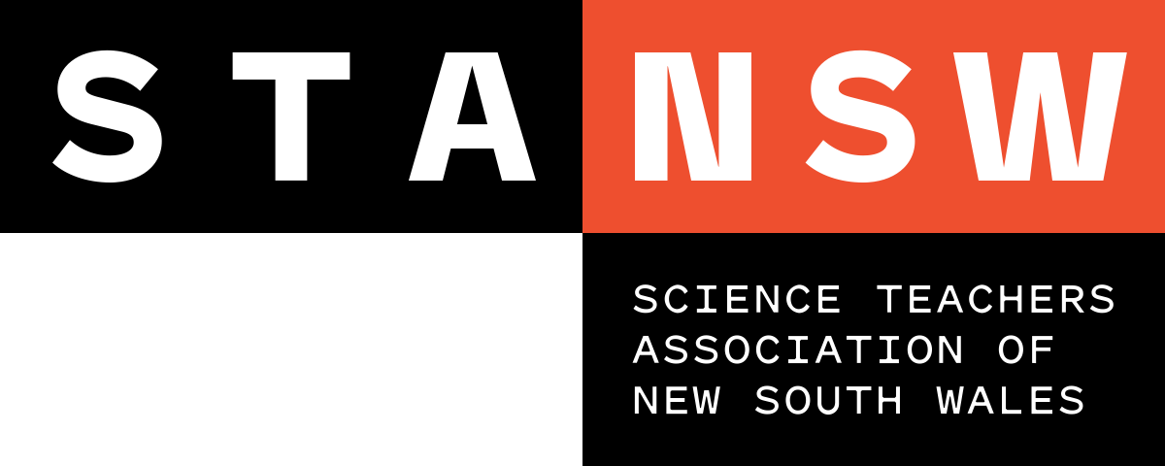
Young Scientist Awards

JUDGING RUBRIC: STANSW Scientific Investigation, Years K-2

Level | Description
5 | The st The student has provided clear and convincing evidence that they:  - actively completed a scientific investigation that incorporated fair testing  - had shown originality in the idea and creativity in the investigative methods  - had a clear understanding of the relevant science concepts  - collected background information and made appropriate predictions  - carefully selected suitable materials and equipment  - collected meaningful and sufficient data  - systematically recorded data and included appropriate graphical display with or without digital technologies  - justified strategies and suggested plausible explanations for the results  - made valid conclusions that show how the investigation is important  - used a logbook to map the progress of the investigation over time  - acknowledged all assistance given  - used effective language and formatting to communicate with the intended audience
4 | The st The student has provided substantial evidence that they:  - participated in a scientific investigation that incorporated fair testing  - had shown some creativity in the selection of the idea or in the methodology  - outlined the scientific concepts related to the investigation  - collected background research with some relevance to the subject of investigation  - made a prediction  - had considered the final choice of selected materials and equipment  - collected relevant and adequate data  - correctly recorded data  - discussed trends and relationships in data collected  - used a logbook to record raw data and tasks performed  - listed any assistance given  - used appropriate language to communicate with the intended audience
3 | The st The student has provided evidence that they:  - participated in a science investigation which incorporated some fair testing  - had shown glimpses of creativity  - had some understanding of the science concepts related to the investigation  - collected fragments of background research  - made some sort of prediction  - used suitable equipment  - collected and recorded relevant data  - analysed data and came to a conclusion  - included a log book that contains notes and ideas  - acknowledged some of the assistance that was given  - used consistent language in all documentation

JUDGING RUBRIC: STANSW Scientific Investigation, Years K-2

Level | Description
2 | The st The student has provided evidence that they:  - attempted a science investigation with minimal understanding of fair testing  - had shown little or no creativity  - had little understanding of the science concepts related to the investigation  - attempted to make a prediction  - collected and recorded some data  - offered poor explanations for the data collected  - included a log book that is minimal or disorganised  - failed to acknowledge assistance given  - used language and formatting that did not connect with the intended audience
1 | The st The student’s report demonstrates that they:  - attempted an investigation with no understanding of fair testing  - had poor understanding of the science concepts related to the investigation  - collected random data  - offered explanations that were not related or plausible  - did not maintain a suitable log book

